Sustainability Annual Report
Year
Name of school

Introduction

ResourceSmart Schools is a Victorian Government initiative that will help our school benefit from embedding sustainability in everything we do. Our school will take action to minimise waste, save energy and water, promote biodiversity and reduce our greenhouse gas emissions.

Sustainability Victoria (and other funding bodies, such as council, Catholic Education Office, etc.) have funded us to participate in ResourceSmart Schools and receive facilitation support from CERES.

Write brief summary on what the goals of this year were, or what the focus was (i.e. student involvement, curriculum, waste reduction etc).

There are five modules in ResourceSmart Schools: Core, Biodiversity, Energy, Waste, Water. Along the way, there are also stars with the ultimate aim to become a 5Star Leadership school.

We have achieved the following stars:

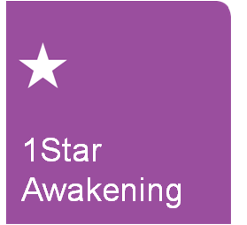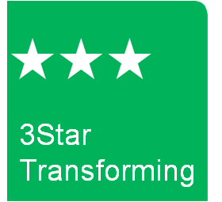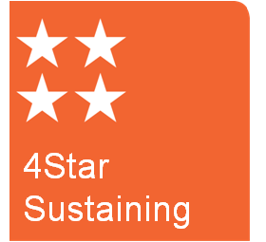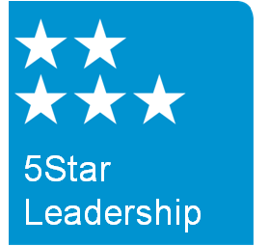

*Delete modules and stars which the school has not achieved yet.

Consumption

Resource | Benchmark  (per student) | Cost  (per year) | Cost  (per student) | Usage  (per student) | Achieving Benchmark?
Electricity | Secondary - 400kWh  Primary - 250kWh
Natural Gas | Secondary -  1.4GJ  Primary - 0.9GJ
Water | 4kL
Waste | 0.3 m3
Recycling | n/a |  |  |  | n/a
Paper | n/a |  |  |  | n/a

*You may like to modify this table or create another to compare you data from the current year to a previous year (eg. your baseline) to be able to demonstrate improvements, financial savings or areas that require additional attention.

Habitat Quality Assessment Score: _____
(Baseline year or previous year: ______)
Overall School Savings: $ ______
(Since baseline year - ____)

*Use the graphs from the Reports section on ResourceSmart Online, eg. compare your usage this year to last year, or compare to your baseline year

**If not achieving benchmarks, detail what actions need to be taken to achieve benchmarks.

Achievements

Give an example of a project or activity the school/classroom/students participated in…

Give an example of a whole school celebration for the module your school has been working on…

Future Goals

List actions school will continue to work on or future goals school will want to work on…

