Tree Planting Day:
As many of you may know, last Friday was Planet Ark’s National School’s tree planting day at Mill Park Heights PS. Each grade was given a plant or two of their own and was helped to plant it by the Environmental tacklers.
Over 100 trees were planted in an area where we are hoping to create an urban bushland. This was a great experience for the kids to get down and dirty also to find out how trees and plants help our environment and eco systems.
On behalf of the Environmental tacklers I would like to say this was an enjoyable and fun experience. I hope everyone had a wonderful time and learnt lots.
The team would like to send a big thank you to Mrs. Ericson and Peter Roberts for all their hard work on tree planting day. Well done to all the Environmental tacklers who helped out and gave a great effort to help our environment.
By Grace McKay
THANKYOU TO OUR GENEROUS SUPPORTERS
Sustainability Victoria for supporting our school with 90 free plants, tree stakes and plant sleeves, through the Million Trees Project.
Thank you to BUNNINGS Mill Park for supporting our tree planting event with $100 worth of plants.
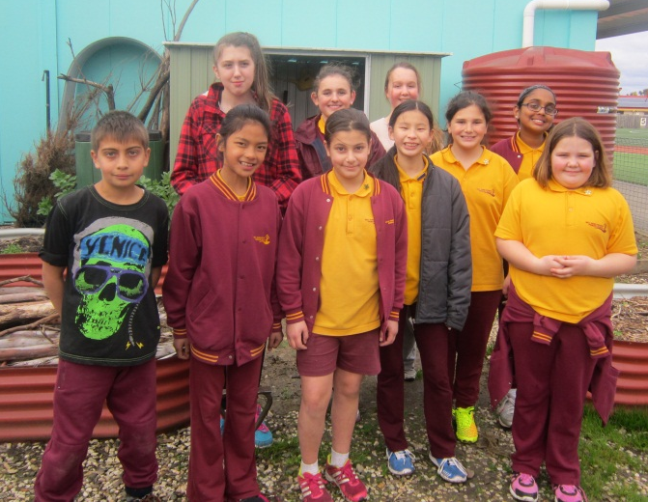
We would also like to extend a big thankyou to the State Parliament Representative for Mill Park, Lily D’Ambrosio for supporting our planting Day event with a very generous personal donation to help purchase plants and equipment for the day.
Thanks to Peter Grenfell from the Darebin Creek Management Group for the loan of some tools and helping out on the day.
Mrs Ericson, The Environmental Tacklers on behalf of the whole school community

