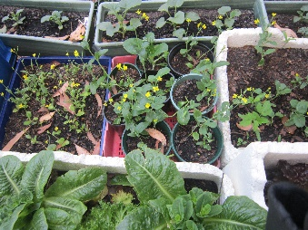
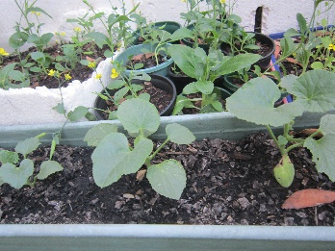
Connected Garden Project and MKPS

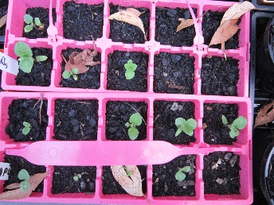
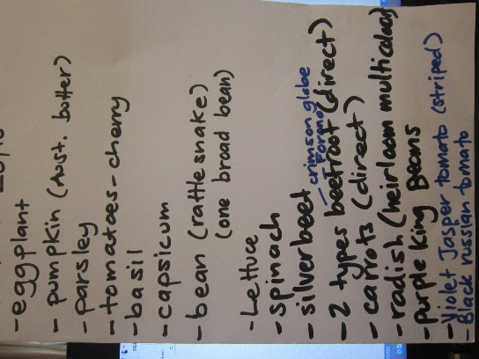
Last year we wrote a letter of support for the Connected Garden Project which was successful and will be running from now until Autumn 2015, and involves all schools in the western corridor of the Murrindindi shire, plus Landcare, Yea Hospital, Rosebank Nursing Home, Yea Children's Centre, Yea Community House and Yea Community Garden. This FRRR McEwan Grant supports a co-ordinator (Zanni Waldstein) to connect food growing throughout the western side of the Shire and will culminate in a Harvest Picnic for all involved in Autumn 2015. The project aims to increase food awareness, food production understandings and to improve healthy eating knowledge in children and the broader community whilst strengthening links between those growing food in the area. This will support all involved to share knowledge, resources and produce from individual garden projects in an on-going way.
The Harvest Picnic Celebration Day will be a gathering of everyone involved to celebrate all of the food growing activities the schools and organisations have been involved in, with the produce grown by each garden to be cooked collectively to make healthy, fresh pizzas (involving a mobile wood fired Pizza oven for the day). It will also involve food based competitions between schools such as biggest pumpkin or vegetable, egg and spoon races, count the beans, blind-folded tomato tasting, eat the watermelon slice, zucchini face carving, recipe inventors, best fruit or vegetable costume and Yea’s biggest fruit salad.
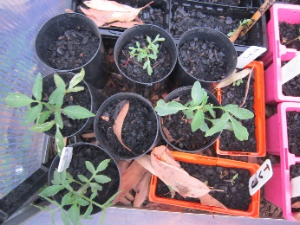
This week Zanni ran two seed raising workshops with Grades 2-4S and 4-6H. The students were really engaged and planted a range of seeds that will be ready for our gardens in the near future. Meanwhile until our sprinkler system is ready to go, our Sustainability Leaders will be busy watering them twice a day. We are busy trying to tackle our problem with slugs too as they need to find another home! A great big ‘Thank you’ to Zanni and to FRRR for helping us with our kitchen garden and including us in the Connected Garden Project.
