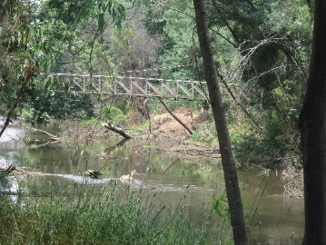
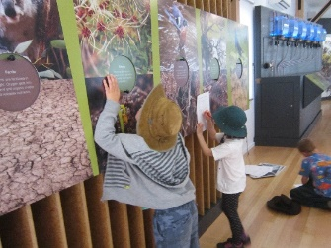
MKPS Prep- Grade 2 Camping Activity Day
Early in December we travelled up to The Yea Y Water Discovery Centre for our camping activity day. We had an early start with breakfast at school in our PJ’s and then changed into our casual clothes for the day’s activities. When we got to the Discovery Centre we split up into two groups. One group explored the Discovery Centre learning about the wetlands and its inhabitants. They found out about the importance of wetlands and ways to protect them. The other group learnt about the traditional owners of the land and how it was utilized in the past. After swapping activities and then morning tea, we broke into three groups and rotated around three stations. Some groups went ponding with Kirsten from Upper Goulburn Catchment Authority, another group learnt about frogs in wetlands with Judy from Landcare, and the third group spent time with Peter from the Discovery Centre learning about the water cycle. Just before we left to head back to school, we had a visit from The Haven Wildlife Rescue Centre. We all loved patting the wombat. The snake and black cockatoo weren’t so keen on being patted! After our trip back to school, the Preps and Grade 1’s headed home and the Grade 2’s slept over at school. It was a great day. Thanks so much to the Discovery Centre for organizing our day.
