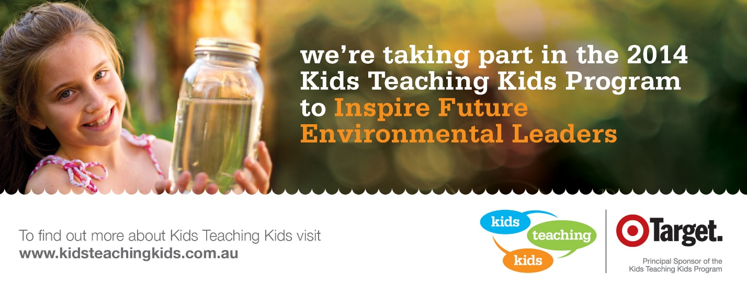
MKPS students join kid’s green army and celebrate 15 years of environment action.
KTK Day is this Tuesday at Yea Wetlands. This is our second year of being involved with KTK at MKPS, however we have been involved in helping the environment for much longer than that. We have always participated in local Landcare planting days and Clean Up Australia Days. We commenced a kerb-side recycling and composting system in 2005 and began applying for Landcare grants to establish some indigenous gardens around this time too. Indigenous plants are ones that grow naturally in your area so they are naturally suited to the weather and rainfall conditions and attract native local wildlife. They don’t require watering as they are accustomed to the weather conditions.
In 2006 we received a Waste-wise award for our waste minimization efforts. We commenced Waste Free Wednesdays prior to our switch to Nude Food Fridays and participated in these programs for around 8 years. Waste-wise grew into AussiVic Resource Smart and now we have also received awards for completing a core sustainability unit, further reducing our waste, increasing the biodiversity of our school grounds and by the end of 2014 we will have achieved awards for minimizing our energy and water use.
We began a lunchtime environmental club Tree Troops a few years ago and now they have renamed themselves The Wildlife Warriors. They have participated in local wildlife days and researched and campaigned to raise awareness about many environmental issues including Leadbeater Possums, whaling in the Southern Ocean, W.A. shark cull, and the endangered bilby to name a few.
Kids Teaching Kids creator Arron Wood, who was Environmentalist of the Year for his environmental education efforts, said that Australia should be proud of its kids’ green army. “Education is their weapon of choice. Green army recruits are all under the age of 17 and they’ve been fighting the good fight for the environment for the past 15 years. Kids Teaching Kids is about empowering the youth of this country to declare war on pollution, habitat destruction and global warming,” Arron said. “Our green-armed forces have been achieving some phenomenal results – whether it’s the restoration of a wetland area or the establishment of a waste water campaign or things as simple as school recycling programs, kids have wonderful ideas and this program allows them to put their concepts into action,” he said.
Karen Faulwetter

