Sustainability- Water a natural resource.

As environmental scientists we have been tuning in and finding out about water, its use and the properties that make up water. In our every day lives we constantly use water from brushing our teeth to cooking to flushing the toilets. As a community we encourage drinking water throughout the day to help hydrate our bodies.

Prior to experimenting with water, food dye and a straw the children made predictions as to what they expected to see- I think it will turn the water green, the whole thing, it will become one colour. I think when Josh uses the straw the water will move and it will look like it has a hole in it.
As scientists they then tested the water and the food dye together. I discovered it made a pattern when it dropped into the water. It didn’t completely change to one colour. The yellow food dye looked red in its little bottle but when it hit the water we could see that it was really yellow. The colours didn’t really mix until Josh blew it, made bubbles and even stirred the water.
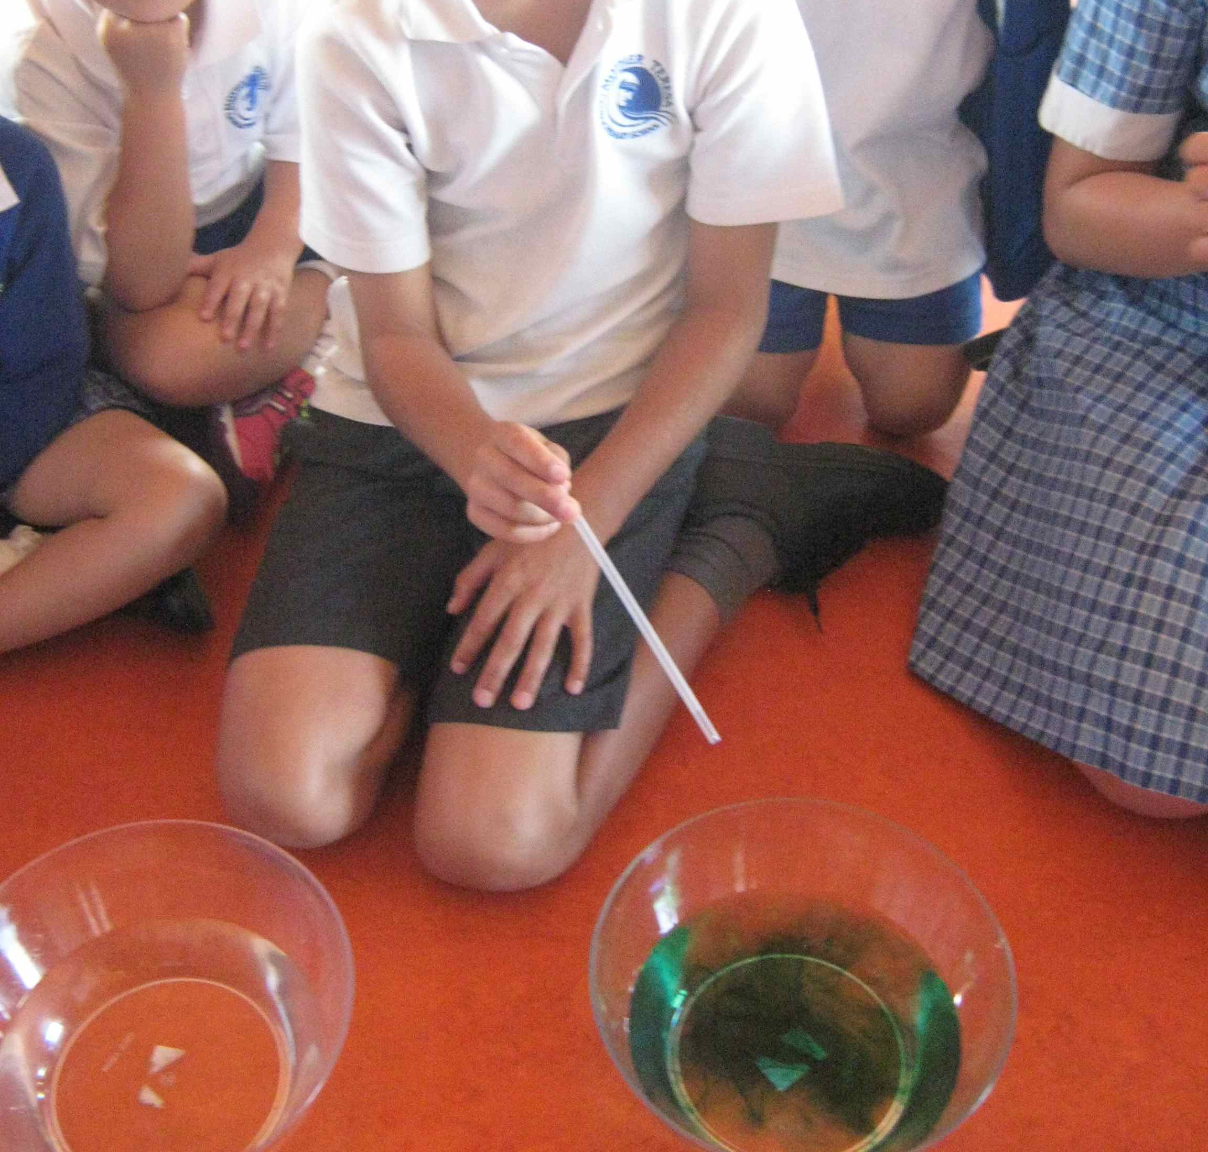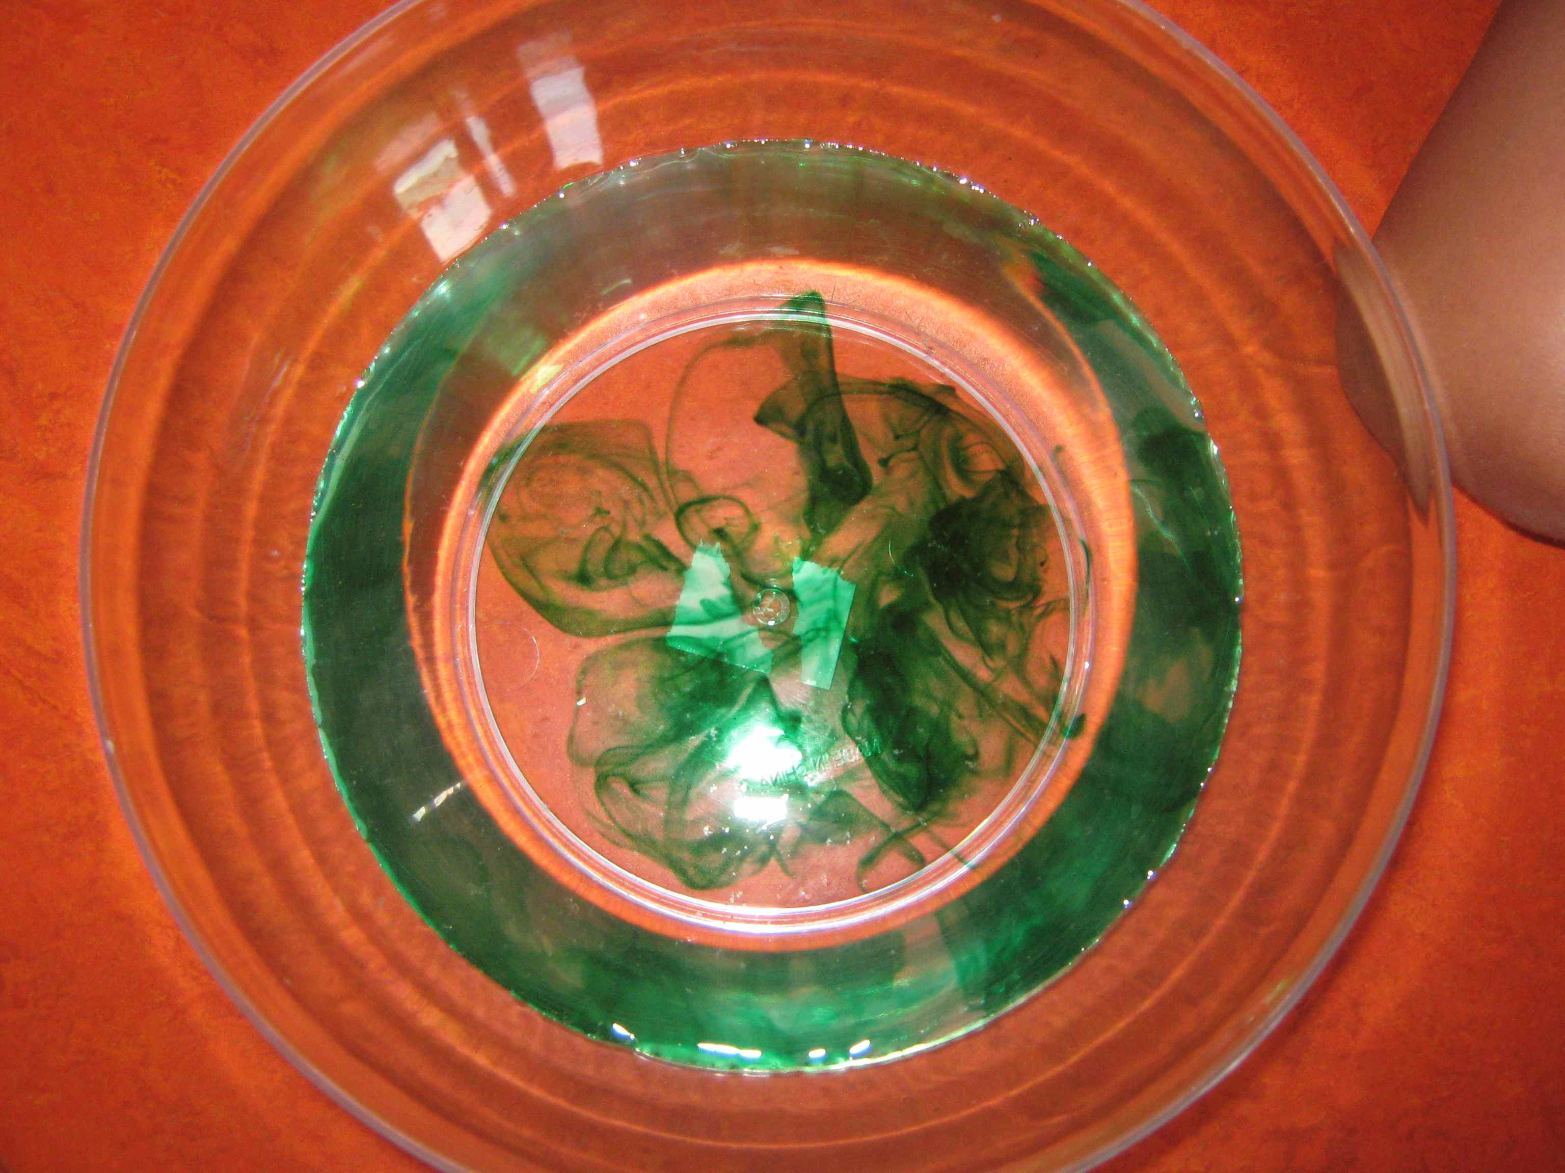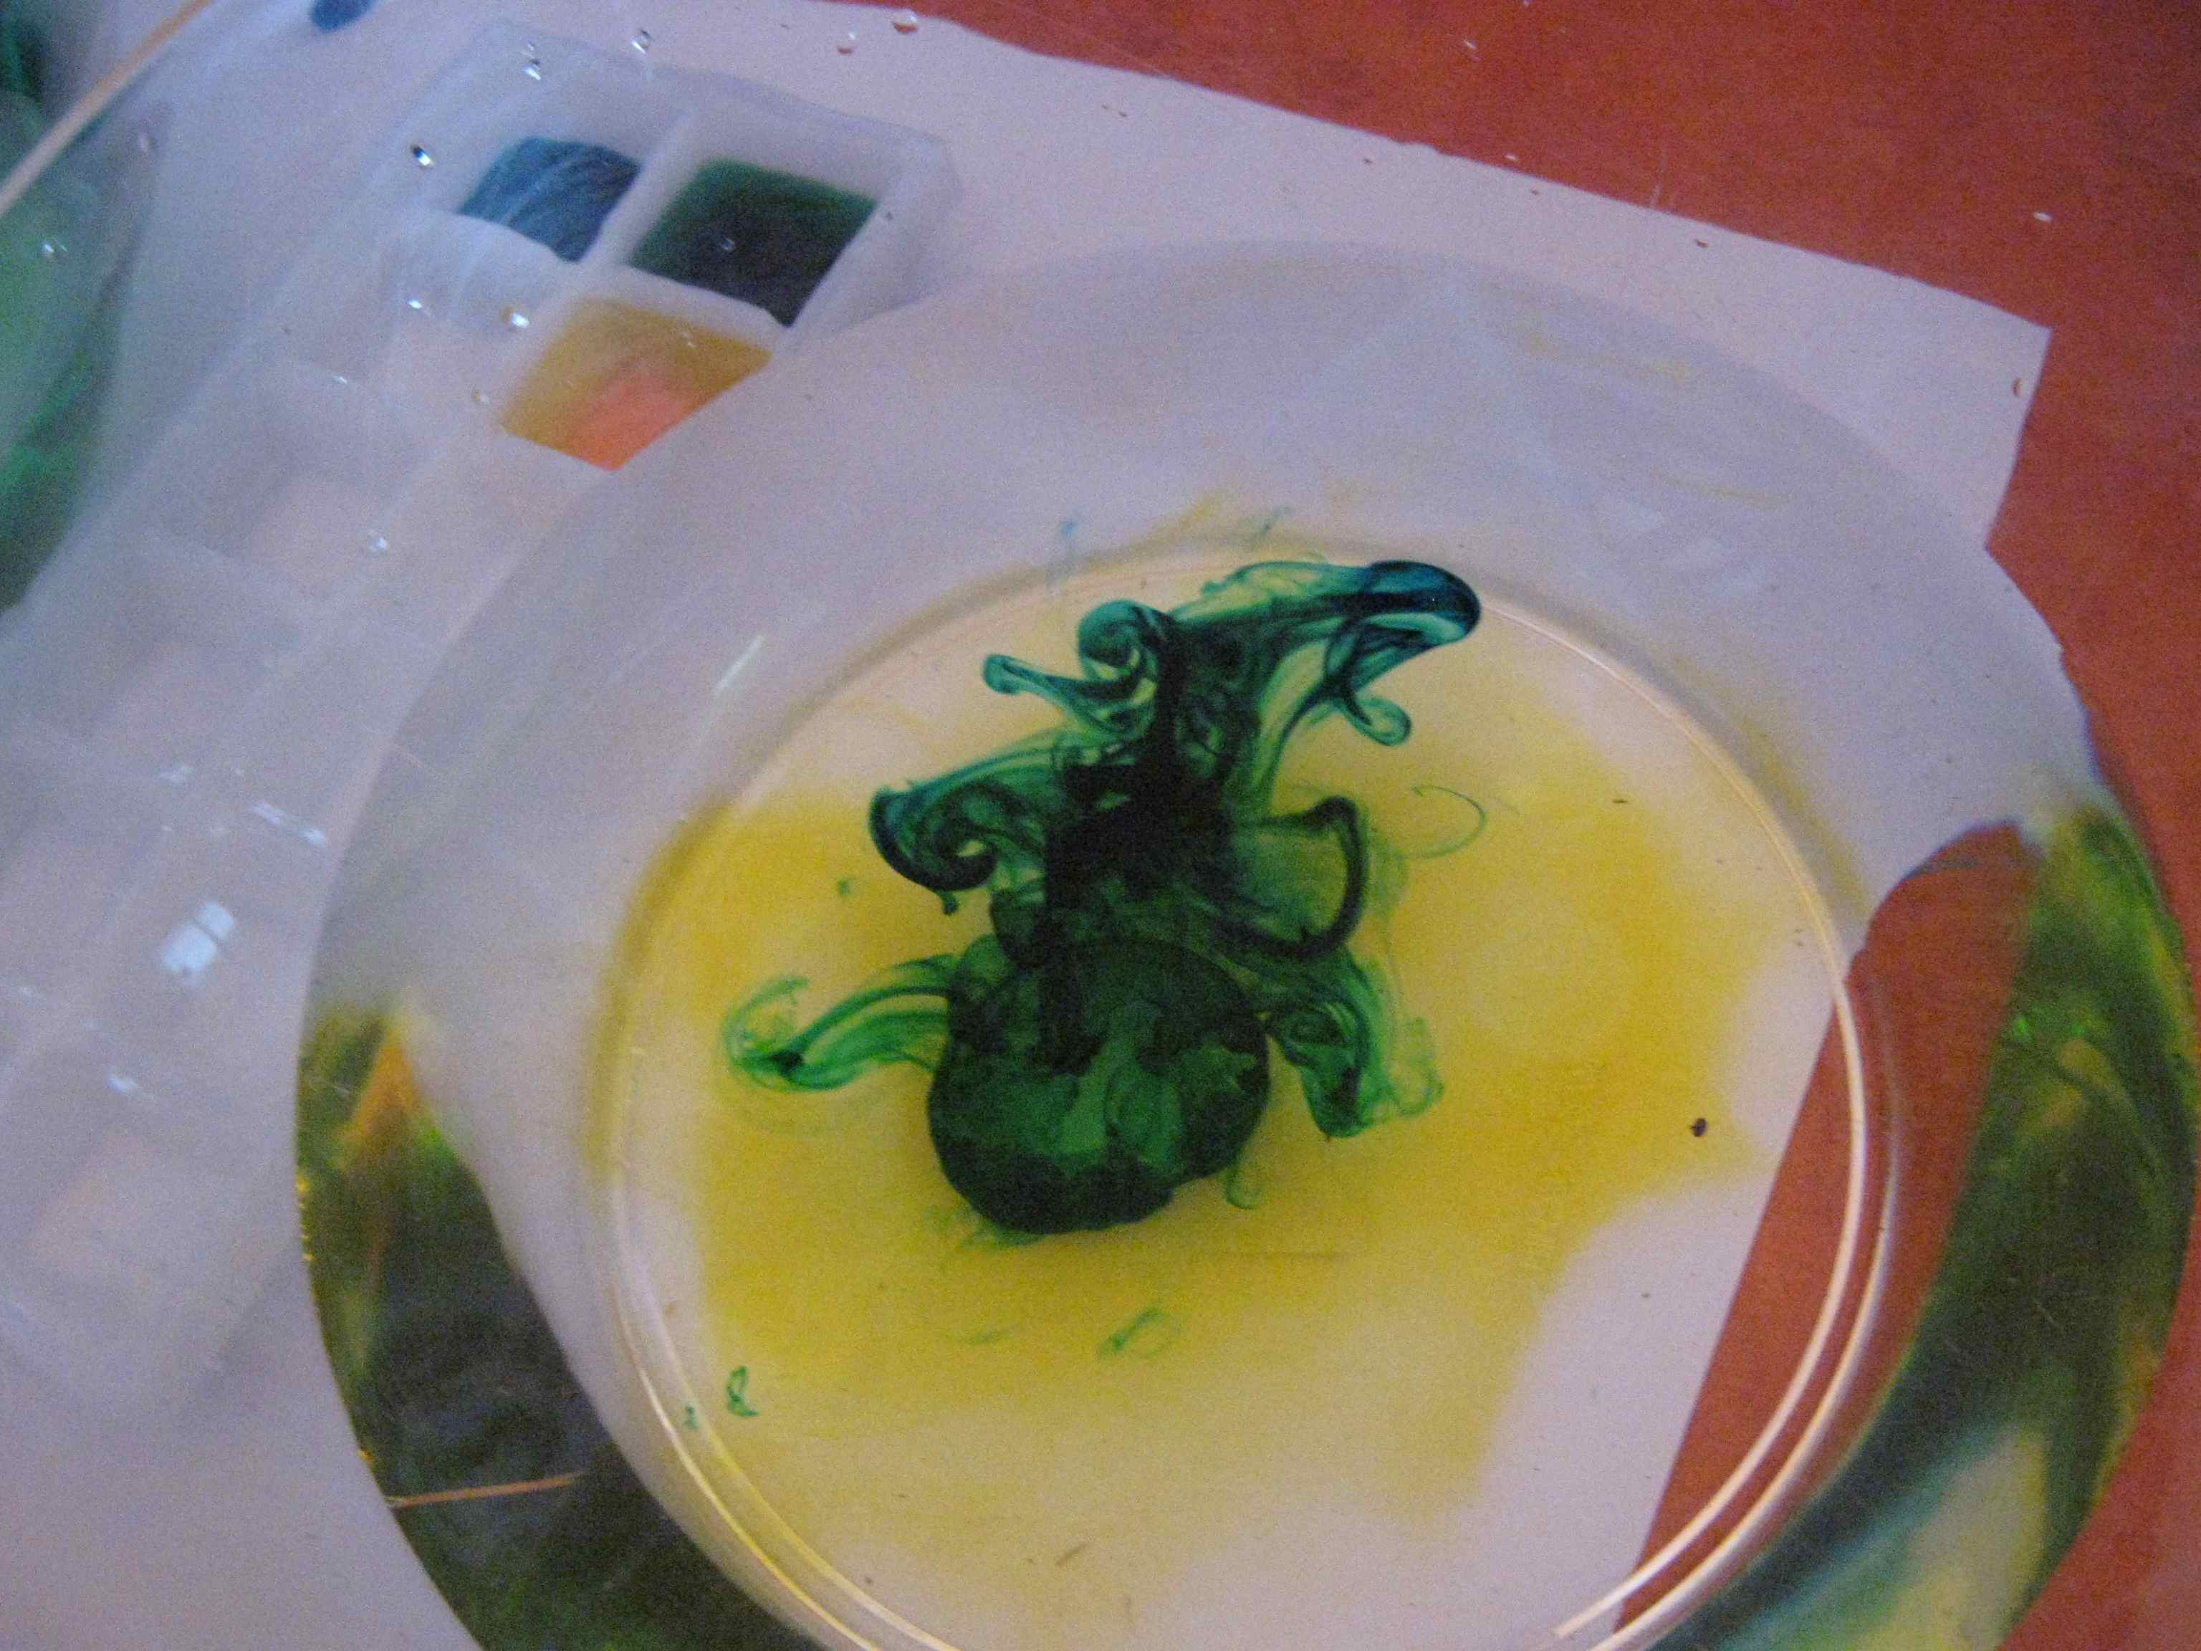
We also filled up an ice cube tray with water including one drop of food colouring and put it in the freezer. One of the observations that was made was the fact that one drop of food colouring in a small space such as the ice cube has a much stronger colour than one drop in a bowl half full with water. We found out it has to do with the volume of the water. It’s like when you mix cordial it depends on how much you add to the glass and how much water you add. We also made the connection to the dye added to the grass seeds they used to seed the new football oval. That way they could tell where they had sprayed and made sure they covered all the areas they needed to.

When reflecting on water and how valuable it is the children said: we need to treat it carefully- not to spill it or squirt it; to think first when we are using it in the garden- is it really needed or is rain coming?; to make sure we hydrate ourselves to keep us healthy as well as the plants.

One of the resources we use as part of being a ResourceSmart AussieVic school is ‘Coolaustralia’. They provide a wide variety of learning tasks as well as information to guide us. In regards to water and its use in Australia here are some facts and figures to take into consideration:

* Most of don’t spare a thought for the amount of water hidden in the food that we eat.
Have a look at how much water it takes to produce some of our favourite foods :
An apple = 70 litres A glass of wine = 120 litres Slice of bread = 40 litres Cup of coffee = 140 litres An egg = 135 litres Hamburger = 2400 litres Leather shoes = 8000 litres
A glass of beer = 75 litres Bag of chips = 185 litres Cup of tea = 35 litres A potato = 25 litres
Glass of milk = 200 litres Cotton t-shirt = 2000 litres One kg of beef = 16000 litres
Visit www.coolaustralia.org for more information on water.

