Clean Up Australia Day – Feb 27th, 2015
The school participates in environmental projects such as Clean Up Australia Day which we did at school on Feb 27th of this year. Each level worked in a different area of the school. It was a successful way to make the students more aware of the need to follow instructions and be more careful with litter from the canteen.
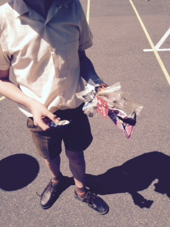
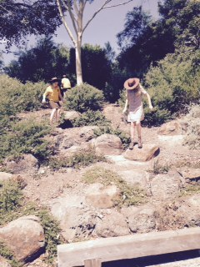

Here are some photos from the day. The students learnt a great deal about the importance of taking care of their school environment and were amazed at the amount of rubbish they picked up. We plan to run one of these each term.
Daniel Phelan
Sustainability Co-Ordinator
St Gregory the Great Primary School

