CASE STUDY Davisson Street 2015

On March 25th 3 student groups performed an Earth Hour concert to encourage students to participate in the following saturday’s Earth Hour. The concert was conducted without the use of electricity to inspire students to think of ways that they could participate in Earth Hour in an entertaining way that doesn’t require the use of energy. Feedback from several attending students and staff were that they strongly agreed with the idea of sticking to the principals of the project and not using electricity but on the whole, the most dominant feedback received was that the concert would have been more powerful had it been mic’ed up!
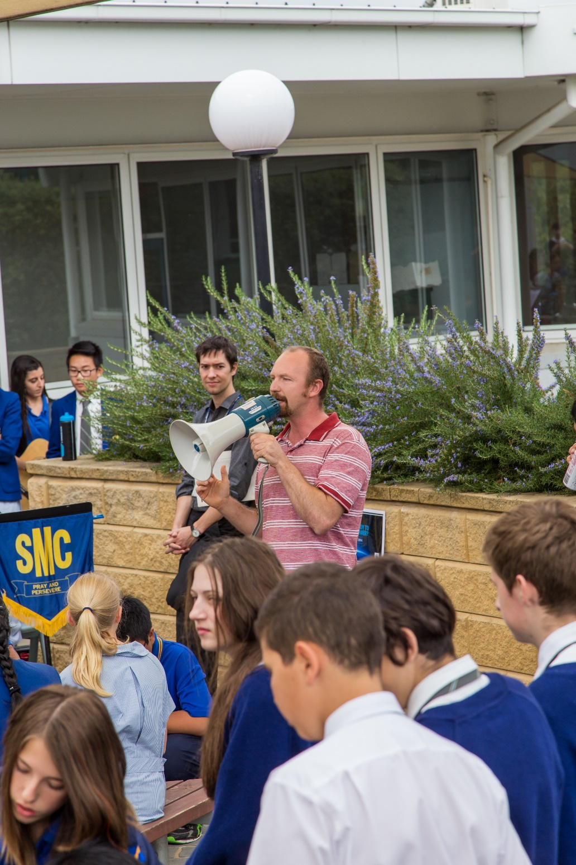

To promote this activity, powerpoints were displayed on the school monitors 2 weeks prior with photos of the event displayed for 2 weeks following the event. On the morning of the day of the concert, the Earth Hour promotional advertisement from you tube was shown to the whole school as well. A reminder note was also sent with a photo of the concert to the school community through our school app. “Skoolbag”

