CLEAN UP DAY
As part of the school’s Sustainability Education Program, the Year 8 students were involved in a “Clean Up” activity on Thursday, 26th February 2015.
The objective of the activity was to instil in our students the value of making a positive difference to our environment and help them understand that each of us play a significant role in helping to keep our precious environment clean and healthy.
Students had a very productive and fun morning picking up litter along Tyner Road and around the Footstar Restaurant and they enjoyed doing their part in helping to keep our environment clean.
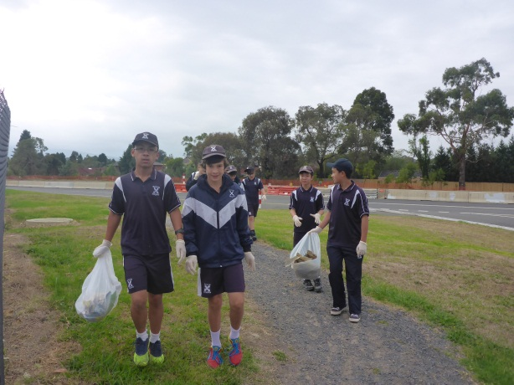 | 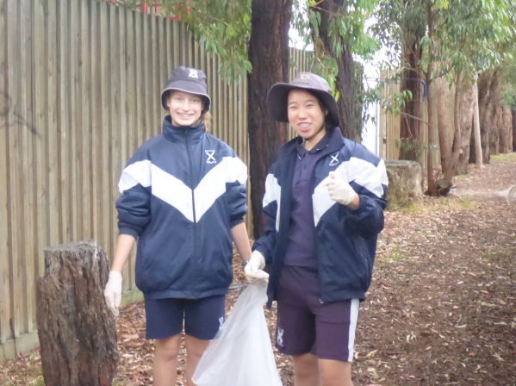
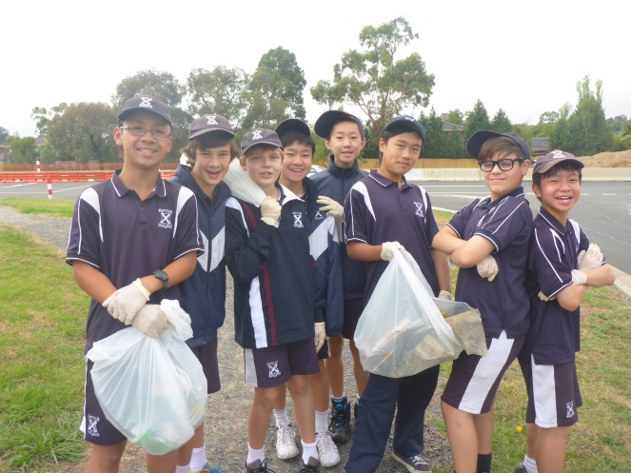 | 