Year 6 recently visited two off school sites to learn about different marine environments, the issues faced by these environments and what we can do to help.
At the aquarium we learnt about a number of different environments and the issues face by these environments. Guides were able to explain these to our students. They include:
Antarctica, which faces the issue of global warming, and habitat loss.
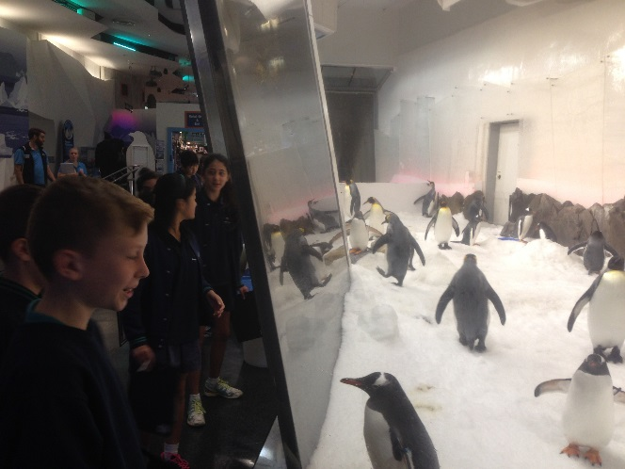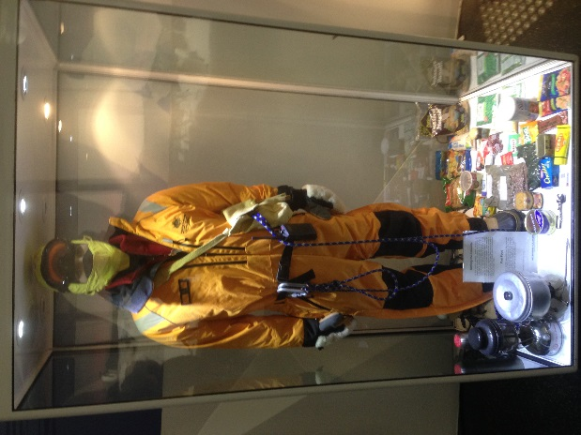
Coral, which acidification, tourism, pollution, tourism
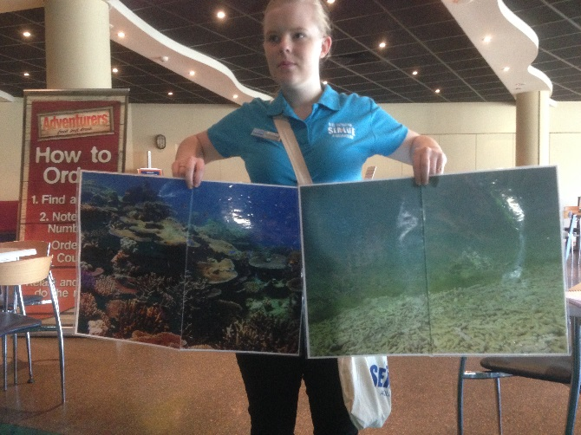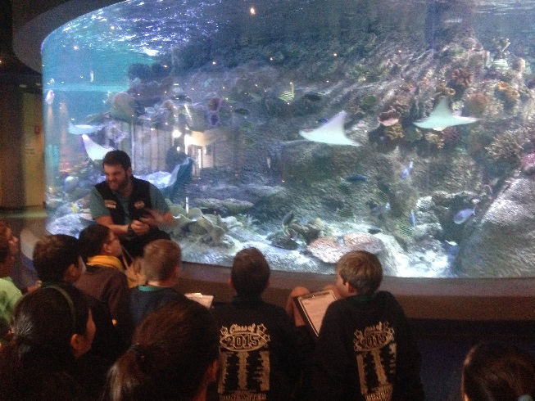
Port Phillip Bay, which faces the problems arising from dredging, over fishing
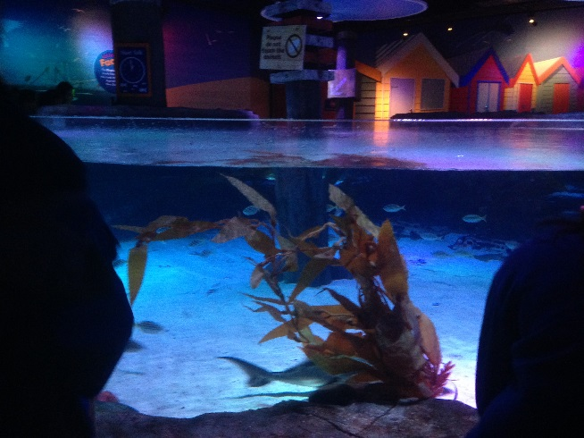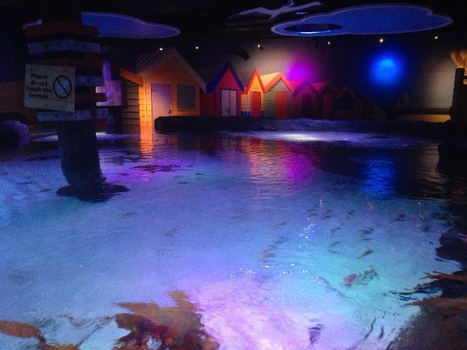
Rockpools: oil spills, introduced species
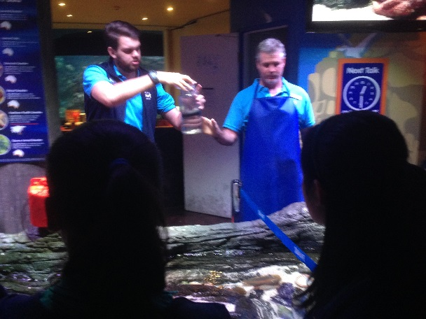
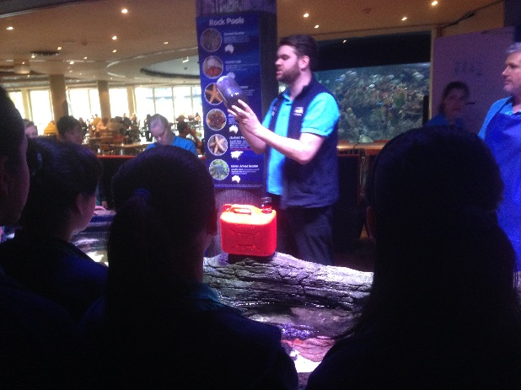
Rainforest: deforestation, loss of habitat, loss of food source
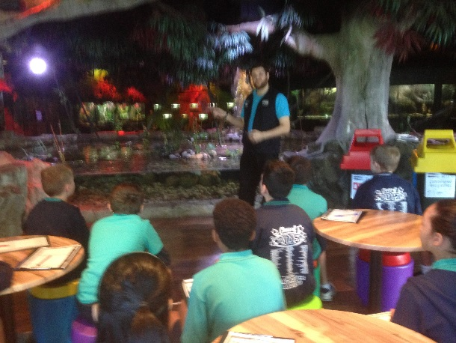
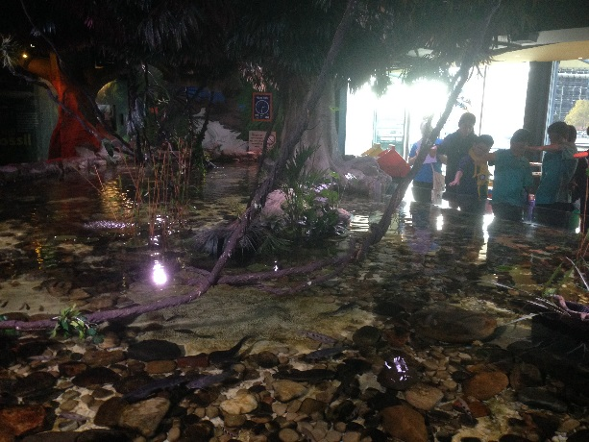
And Ocean, ocean warming, acidification, overfishing,
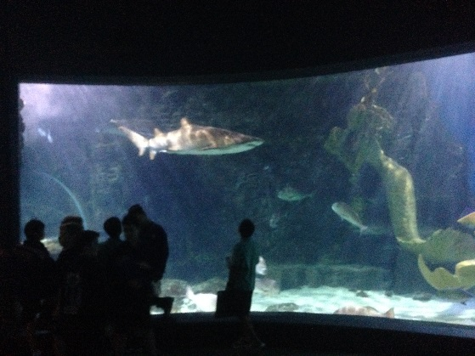
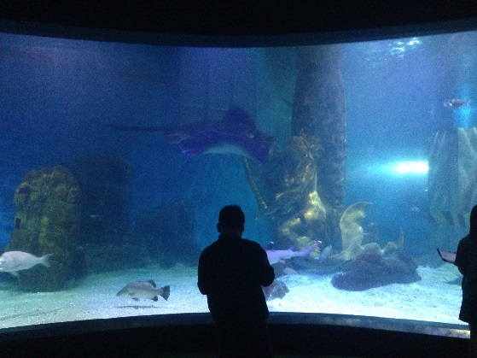

We also visited Ricketts point learning about pollution and how it affects the coastal environment. Here we were met by guides from the Dolphin Research Institute that showed us important measures in castal care, the different marine creatures that require our help, and what we can do to protect them.
