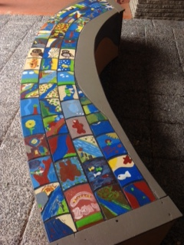
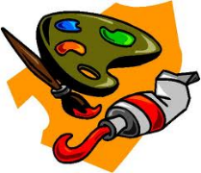
Our New Art Sculpture
Last September Mrs Ericson organised for two of our Grade 6 classes to have a visit from Melbourne Water and artist Peter Day to work on producing a community art sculpture as a part of a project our Environmental Team was involved in. Mill Park Heights was very lucky to be asked to be involved in this art sculpture because only 200 students from 4 schools across the state were asked to contribute to the project.
The students spent the first part of a session exploring what they knew about the Yarra River and the effect that humans were having on the famous waterway with the Melbourne water staff. Then they were asked to paint a small wooden tile inspired by the flora and fauna of the Yarra River mentored by the artist Peter Day.
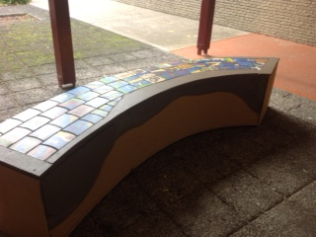
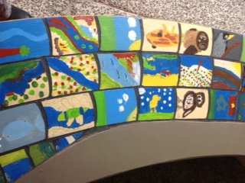
Once completed, the tiles were attached as part of a giant structure 4 meters long that represented a snaking river. The finished sculpture was the centrepiece of the kids teaching kids conference that our Environmental Team presented at last year at the Yarra Conference in Warrandyte. At the end of the conference the whole sculpture was moved to Federation Square to be displayed there for a few months. Now that the exhibition has finished the schools that participated in the project were offered a section of the sculpture. As you may have noticed our section of the sculptured was placed in the alcove outside the grade 6 classrooms opposite room 2 and adjacent to the art room at the end of last term. A fitting space for such a wonderful addition to our school yard showcasing our past students artwork.

