Tree Planting Day
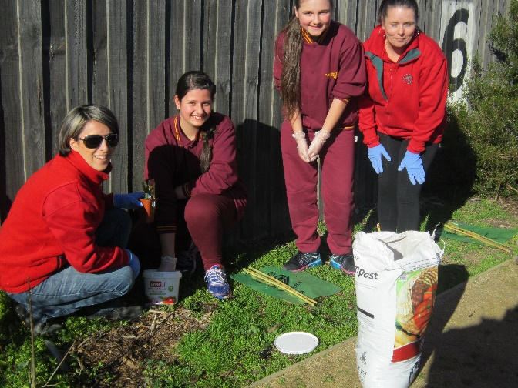
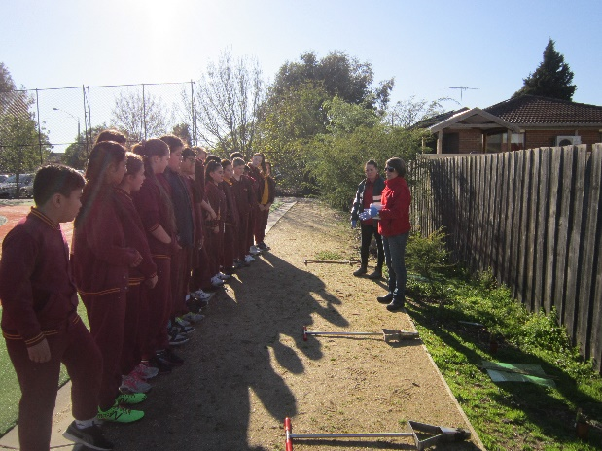
As many of you may know, on Monday we ran a Planet Ark Tree Planting Day with all grade 6 students. This event was generously sponsored by Bunnings Mill Park. We were very pleased to have such nice weather to complete the planting. Each grade was given three or four plants of their own and were helped to plant then by the Environmental Tacklers and the Bunnings staff, Michelle and Debbie.

The remainder of the plants will be planted on Friday when we run our traditional National School’s Tree Planting Day Event, with the rest of the school. So Stay tuned for more pictures of this event next week.

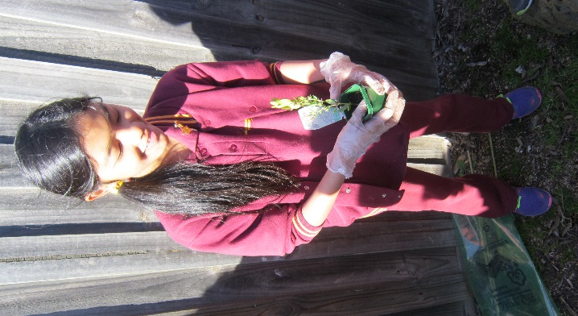
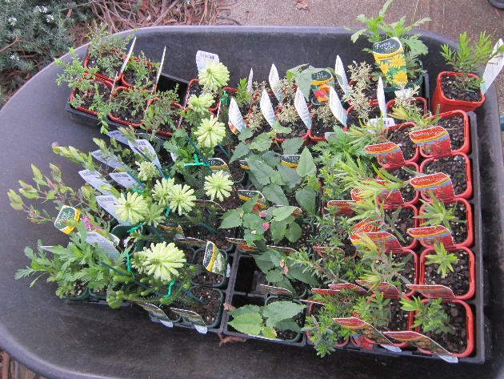

Thank you to BUNNINGS Mill Park for your generous support of our tree planting event with 80 native plants, bamboo stakes and tree guards.
Mrs Ericson and the Environmental Tacklers

