The Melbourne Water Environmental Leadership Conference
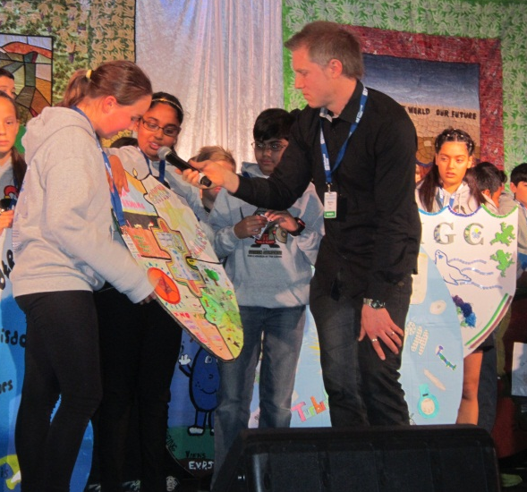
On Thursday the 30th July and Friday the 1st August 8 of the Environmental Tacklers went to the Melbourne Water Kids Teaching Kids Conference at Etihad Stadium and Collingwood Children’s Farm.
Before the event all the schools involved were asked to make a shield to show what their school does to help the Environment. This is the shield we made. Most Team members each made a piece about a different aspect of our school’s Environmental Journey.
On the first day of the conference we were at Etihad Stadium! When we got there we got to pick a hoodie with the water warrior emblem we wanted. We were then given a kit bag with a drink bottle, a hat and some seeds. We then got name tag lanyards with our name, school and activity groups on it.
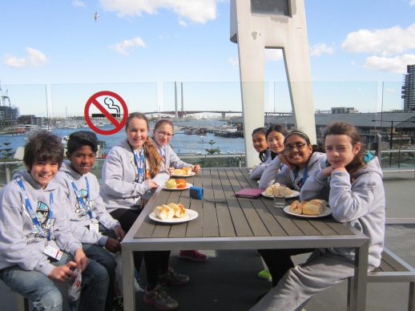
To start off the day we had a performance in acknowledgement to the traditional owners of the land. After we watched some presentations from different schools we went off to our workshops. Our school group was broken up into different groups, so we weren’t all together. We visited 4 workshops on Thursday, all run by primary and secondary schools. One of the best was St Macartan’s School. It was interesting, interactive and well presented. Also the workshop called “Percy saves the day” was well enjoyed by most.
For lunch that day we had a selection of rolls and juices.
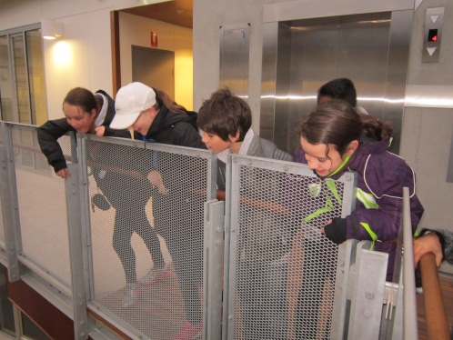
After our last workshop, we went on a tour of the lend lease building. It showcased many environmental things, but one of the most out there was, THAT IN 2 SPOTS THERE WAS NO ROOF. So on a rainy day like Thursday, the rain came into the building.
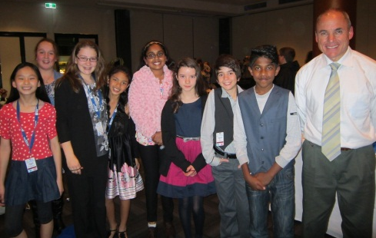
When we got back to Etihad Stadium we had over an hour until our Gala Dinner. We played Uno all together and had a lot of fun. Then we started getting ready. It was a formal dinner so everyone had dressed up and done their hair nicely.
Once we were seated, the waiter came around and poured us something to drink. Then the night got under way. There were a few performances and appearances by some people including, Mike Larkin from channel ten! We had pasta for dinner and we all agreed that it was worth the wait because it was delicious. We had strawberry ice-cream with chocolate topping for dessert. After dessert a band started playing music, so us girls got up and danced the night away.
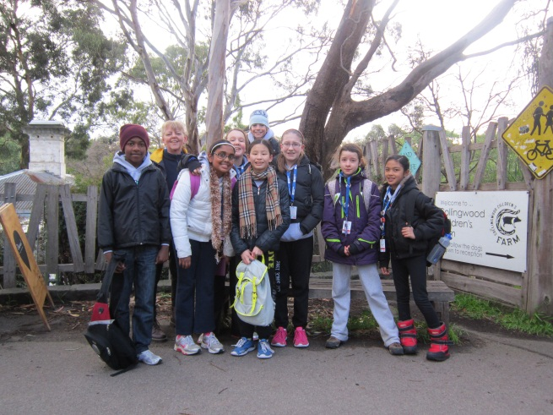
By Julia 6JK
Day 2 – Collingwood Children’s Farm
On the second day of the Water Conference, the Environmental Tacklers, Mr Roberts and Mrs Ericson went to Collingwood Children’s Farm to learn more about water.
There was composting, having a farm tour and building a stormwater garden. Composting was very interesting, we learnt about the types of worms used in composting and the balance of having carbon and nitrogen products in the compost.
Some of us were learning about water bugs, tiny bugs in our waterways to determine how clean it is. There were different types of water bugs ranging from the backswimmer to the water mites. If we have the more sensitive water bugs in our waterway, it means that our water is clean and healthy.
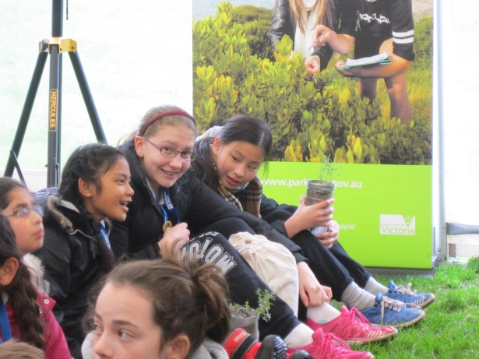
Many people enjoyed building a miniature stormwater garden. It was made out of a recycled plastic bottle cut into half. The half with the bottle cap on, we put a piece of netting. Next we put a cup of rocks and in addition, a cup of sand. Then we got a plant each to plant inside the bottle filled with rocks and sand. Next goes 2 cups of sand and soil to cover the plant up, finally a cup of rocks to finish our stormwater garden. The purpose of a stormwater garden is to filter the water that runs off houses and apartments so by the time the water gets to our waterways it won’t be as polluted.
During our time at the Kids Teaching Kids, Water Conference we have learnt many important things to take with us to help make Mill Park Heights more environmentally friendly. By Joyce 6JM
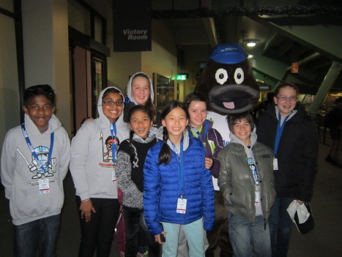
The Team would just like to thank Mrs Ericson, for organising for us to go to the Water Conference and coming with us on the 2nd day. Mrs Becker, for taking us on the 1st day and Mr Roberts for coming along on both days. Also parents Mr Andrews, Ms. Boca and Mrs Ray for picking us up after the Gala dinner.

