Energy Saving Checklist for Training Rooms
Please go through this checklist if you are the last to leave this room.
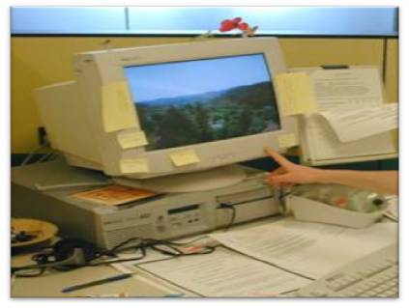
Please switch off:
Lights
Computers
Monitors
Heating/cooling
Ceiling Fans
Printers
Other appliances

