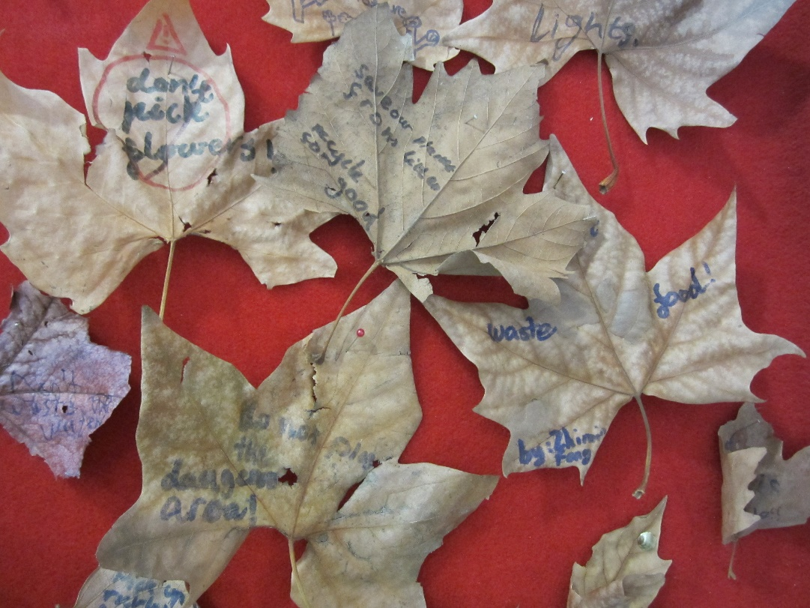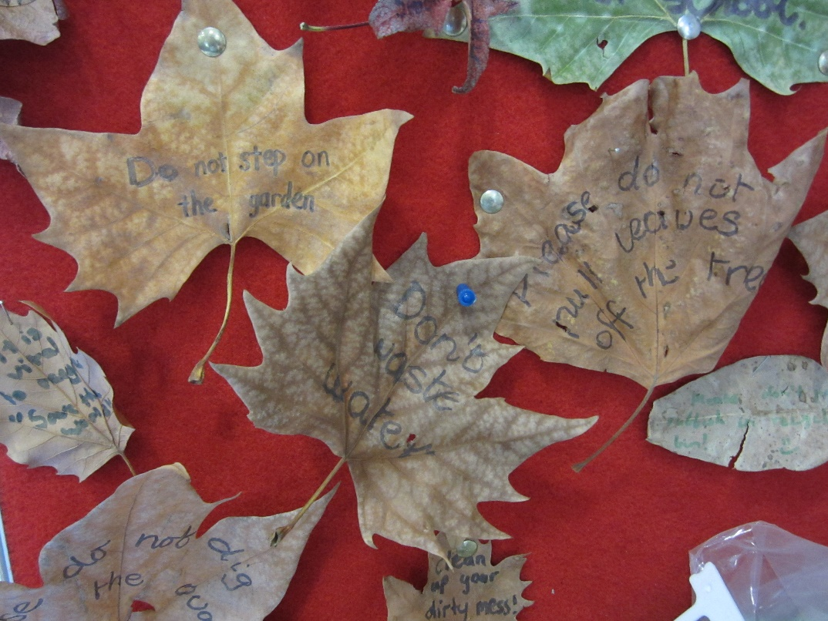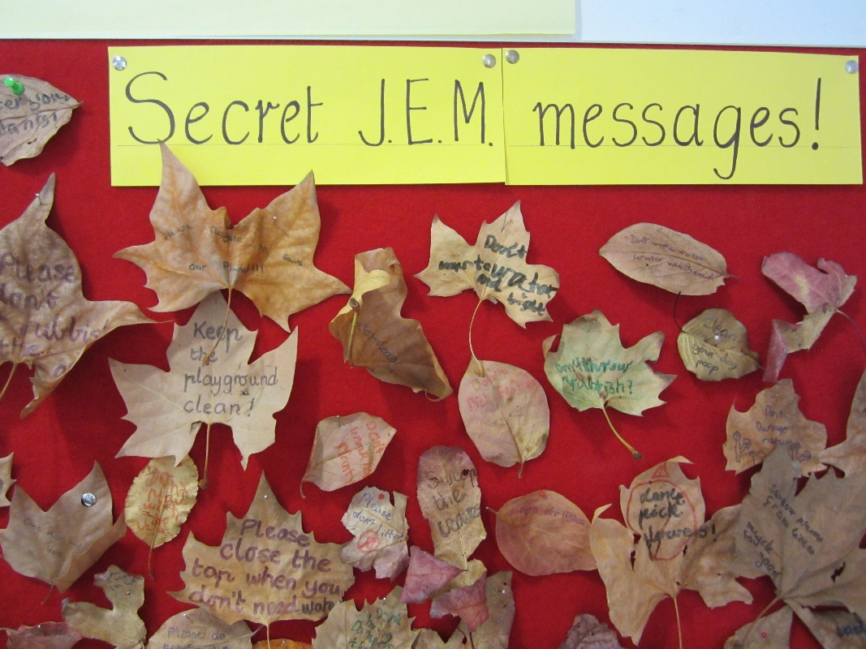
Students who come to EAL lessons have been learning about Autumn, the months of the year and unusual plural words – for example leaf/leaves. As we are a JEM school – Joint Environment Mission – we care for our school environment by:
turning off lights when we leave the room; saving water by catching the waste water from the drinking taps and putting this on our garden beds; keeping our gardens clean; starting a vegetable garden; avoiding bringing rubbish (wrappers) in our lunchboxes; saving energy in the classroom.

Students have scattered these leaves around the school to celebrate the last day of Autumn! If you find a leaf with a message, please take it to your classroom teacher. If you read it out to the class, you may receive a reward!
Let’s all work to make our environment healthy!
Mrs Cullen and EAL students

