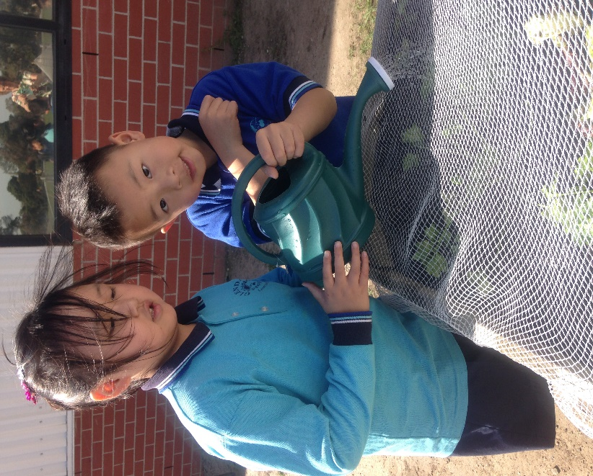**Ne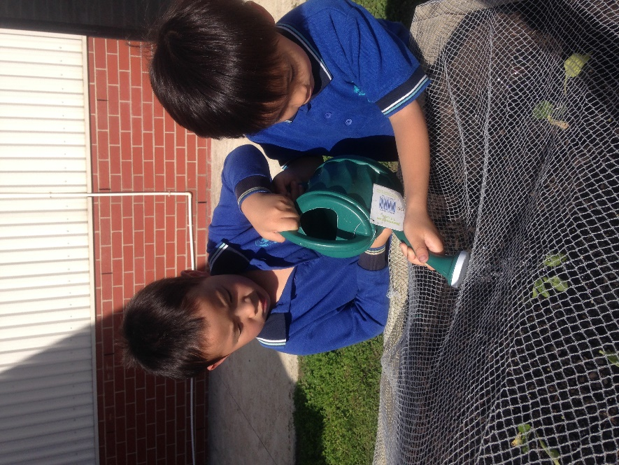w Vegetable Garden**

As part of our JEM school initiatives, students who come to EAL classes have been the first to start our Glendal veggie garden. These students from Prep to Grade 6 have planted parsley, silverbeet, garlic, lettuce, rocket and Chinese cabbage.

We will measure the growth, keep the birds away and water when there is no rain.

What recipes will we make with these ingredients?

Wendy, Edward, Alex and Ivan from Grade 1 are carefully watering the parsley.