WASTE NOT, WANT NOT
James Cook Primary has been aware of the difficulties we all face with disposing of waste produced at school and within the local community for a long time. This year we have endeavoured to tackle the issue head on by attempting to reduce, recycle and reuse the items we no longer require as opposed to discarding it all to land fill.
We have sought the expertise and experience of CERES and Resource Smart to guide us through both student and staff in-servicing, group consultation and individual visits.
Green Team is an ongoing group of children from all grades that meets weekly to discuss the progress of our sustainability efforts and to address needs such as nude food, tree planting, watering, bin emptying, compost turning, assembly reports and project creation.
With the assistance of the children their families we have encouraged ‘Nude Food’ therefore significantly reducing the amount of wrappers brought to school.
Waste audits have commenced to ascertain what we are disposing of and whether the correct decisions are being made.
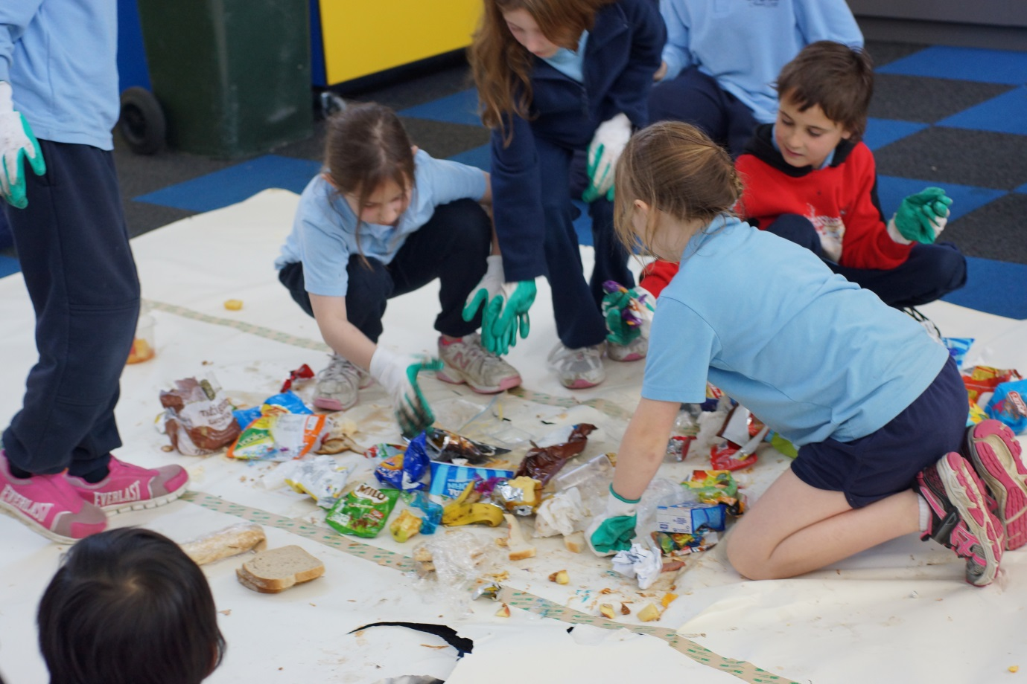

We have re-established our garden patches to grow edible fruit, vegetables and herbs. Bunnings have assisted with support, discounts and generous donations in this area.
Composting regimes have been created in classroom modules with associated bins placed next to all outdoor areas.
Casey Council has supplied us with a substantial grant to assist us in reducing our waste and have also provided new recycling bins which are placed in classrooms to ensure paper, cardboard and bottles are disposed of correctly. They have supported us through visits, in-servicing and ongoing suggestions and advice.
We have collected clothing and toys which were gifted to the SIDS Foundation.
A major change has been in our curriculum where sustainability has become an ‘Inquiry through line’ across all school levels.
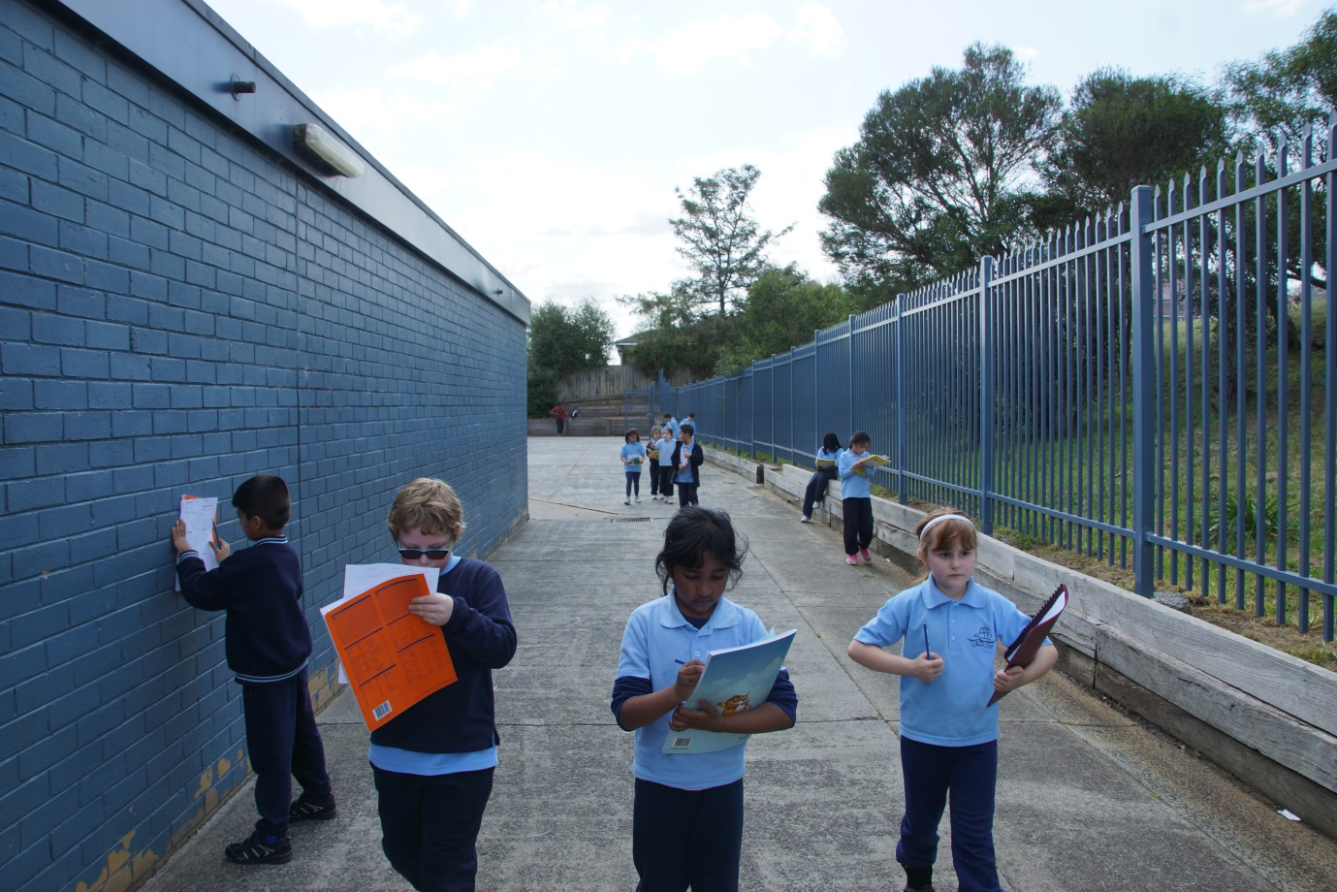
We are creating a community that is at least aware of the need to attend to our waste problem and at best a group committed to doing something about it.

