A Very Busy Term 3 for The Burke Hall Environment Group

During the Winter holidays the long awaited BH Environment Group stream and pond Biodiversity area was completed by a landscape gardening team. The original idea for the pond was initiated and planned for by the BH Environment Group. Student members of the BH Environment group will do further planting out and be involved in the upkeep of this wonderful new addition to the BH Campus.
The third term itself started with a Sustainability Meeting for all Burke Hall Staff in which all staff learnt more about the ResourceSmart Schools program run by Sustainability Victoria and worked in a variety of groups on finalising the SEMP (School Environmental Management Plan) for our campus.
The following week the BH Environment Group organised and ran the BH School Assembly. There were songs, prayers, information, prizes, audience participation and a very captivating mock Debate with a Climate Sceptic (Professor Hanson from Qld did look a little like Mr Sullivan from Kostka Hall according to some staff..?!)
In the assembly we also promoted the upcoming BH Environment Day which was held on Friday August 5th. On Environment Day there was much Green to be seen everywhere and there were many activities including Guest Speakers from the Friends of the Earth as well as Old Xaverian Mr Gerry Ryan who spoke of his work helping to save endangered animals around the World. The Greenest classes this year were Yr 6 Rodriguez and Yr 4 from the Early Years and both classes will take part in bushwalk/picnic days in Yarra Bend during Term 4 this year.
And still to come this term the BH Environment Group will be doing more planting out around the new stream and pond as well as planting more vegies in the vegie patch to be ready for harvest before our BHEG end of year lunch this year.

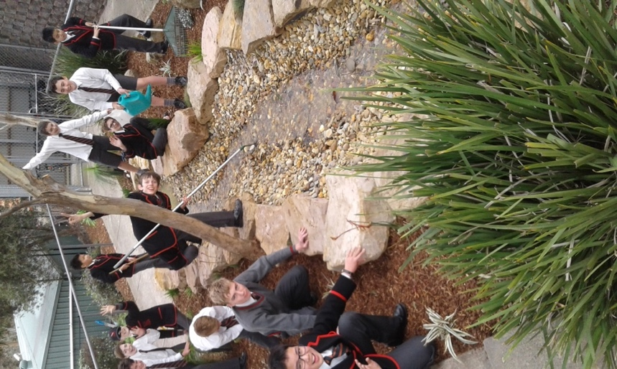
BH Environment Group members around the new Stream/Pond Biodiversity area

