Your School’s Name

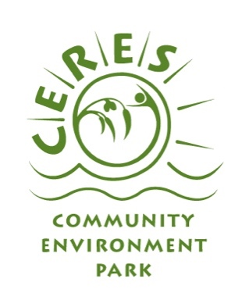
* Your school’s logo here

School Environmental Management Plan
Date-Date

This School Environmental Management Plan (SEMP) outlines your school commitment to sustainability. It highlights our achievements to date and a plan for what we would like to achieve in the future.

This SEMP has been developed as part of ResourceSmart Schools, which we joined in year. ResourceSmart Schools is a Victorian Government initiative that will help our school benefit from embedding sustainability in everything we do. Our school will take action to minimise waste, save energy and water, promote biodiversity and reduce our greenhouse gas emissions. Sustainability Victoria and organisation’s name (if further funding provided) have funded us to participate in ResourceSmart Schools and receive facilitation support from CERES.

Our SEMP is made up of the following key documents:
- Education for Sustainability Vision
- Sustainability Policy
- Green Procurement Policy
- Implementation
- Curriculum Review

Ratified by School Council on: date
Date of next review: date
A. Education for Sustainability Vision

B. Sustainability Policy

Rationale

Guidelines

Energy -

Waste -

Biodiversity -

Water -

Aims and Targets
Benchmark targets are set by Sustainability Victoria

Biodiversity | Energy | WASTE | Water
Increase habitat quality assessment score:  Every year from baseline year | To achieve benchmark of:  250 kWh – electricity  0.9 GJ – natural gas  0.4 tonnes CO₂  per student / per year | To achieve benchmark of:  0.3 m³  per student / per year | To achieve benchmark of:  4 KL  per student / per year
Aspirational Target: | Aspirational Target: | Aspirational Target: | Aspirational Target:

C. Green Purchasing Policy

Rationale

Guidelines

When feasible, your school will:

D. Implementation

In this snapshot we are documenting our campus, curriculum and community actions and identifying opportunities for improvement. We are also identifying opportunities to shift our whole school culture to take action on climate change.

BIODIVERSITY | Current Practices | Future Goals | How we will achieve our future goals
Campus
Audit Investigations, Habitat Gardens, Food Gardens, Maintenance & Protection
Curriculum  How Biodiversity is embedded into learning and teaching and creating opportunities for students to participate in hands-on projects. | See Curriculum Review
Community
Building links with the school community and local community organisations and groups.
Culture
Whole-of-school approach to increase awareness and knowledge of biodiversity issues.

ENERGY | Current Practices | Future Goals | How we will achieve our future goals
Campus
Audit Investigations, Computers and Electronic Equipment, Lighting, Heating and Cooling, Renewable Energy
Curriculum  How Energy is embedded into learning and teaching and creating opportunities for students to participate in hands-on projects. | See Curriculum Review
Community
Building links with the school community and local community organisations and groups.
Culture
Whole-of-school approach to increase awareness and knowledge of energy issues.

WASTE | Current Practices | Future Goals | How we will achieve our future goals
Campus
Audit Investigations, Green Purchasing, Waste Systems for: Landfill & Recycling, Electronic Waste, Paper, Reusing, Litter
Curriculum  How Waste is embedded into learning and teaching and creating opportunities for students to participate in hands-on projects. | See Curriculum Review
Community
Building links with the school community and local community organisations and groups.
Culture
Whole-of-school approach to increase awareness and knowledge of waste issues.

WATER | Current Practices | Future Goals | How we will achieve our future goals
Campus
Audit Investigations, Water Systems for: Mains Water, Water Collection, Storm Water, Gardens
Curriculum  How Water is embedded into learning and teaching and creating opportunities for students to participate in hands-on projects. | See Curriculum Review
Community
Building links with the school community and local community organisations and groups.
Culture
Whole-of-school approach to increase awareness and knowledge of water issues.

E. Curriculum Review

We are committed to including a sustainability/environmental focus into inquiry units across all year level and as part of daily classroom practices where possible.

Year | Name of Inquiry Unit, Curriculum Area or Learning Activity | Biodiversity | Water | Waste | Energy
F
1
2
3
4
5
6

