YOUR SCHOOL’S NAME

* Your school’s logo here

ANNUAL REPORT - SUSTAINABILITY
YEAR

ResourceSmart Schools is an award-winning Victorian Government program that assists schools to embed sustainability in everything they do, encourages real-life sustainability learning and helps schools save money.
Our school is taking action to minimise waste, save energy and water, promote biodiversity and reduce our greenhouse gas emissions.
Sustainability Victoria (and other funding bodies if applicable, such as Council, Catholic Education Melbourne, etc.) have funded us to participate in ResourceSmart Schools and receive facilitation support from CERES.
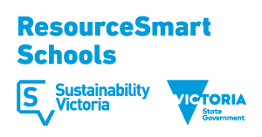

Date: 04/09/2019

A. RESOURCESMART SCHOOLS PROGRESS

There are five modules in ResourceSmart Schools: Core, Biodiversity, Energy, Waste, Water. Along the way, there are also stars with the ultimate aim to become a 5Star Leadership school.

We have achieved the following modules:

We have achieved the following stars:

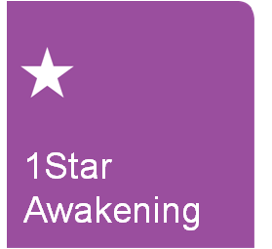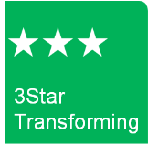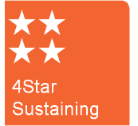

*Delete modules and stars which the school has not achieved yet.

B. RESOURCESMART USAGE AND SAVINGS

Benchmark Performance

Benchmark targets are set by Sustainability Victoria

Resource | Benchmark (per student/year) | Total cost 2018 | Total usage 2018 | Cost per student 2018 | Usage per student 2018 | Achieving Benchmark?
Electricity | 250kWh(primary)  400kWh (secondary)
Natural Gas | 0.9GJ (primary)  1.4GJ (secondary)
Water | 4kL
Landfill | 0.3 m³
Recycling | n/a |  |  |  |  | n/a
Paper | n/a |  |  |  |  | n/a

Biodiversity
Habitat Quality Assessment Score:
Number of trees planted in 2018:

Renewable Energy Generation (solar)
Total generation 2018:

Savings

Since our baseline year of year we have saved a total of $xx.xx
In the past 12 months, we have saved $xx.xx per student.

This equates to the following environmental savings:

*Insert screenshot of savings from dashboard on RSS Online

C. ACHIEVEMENTS

D. FUTURE GOALS

