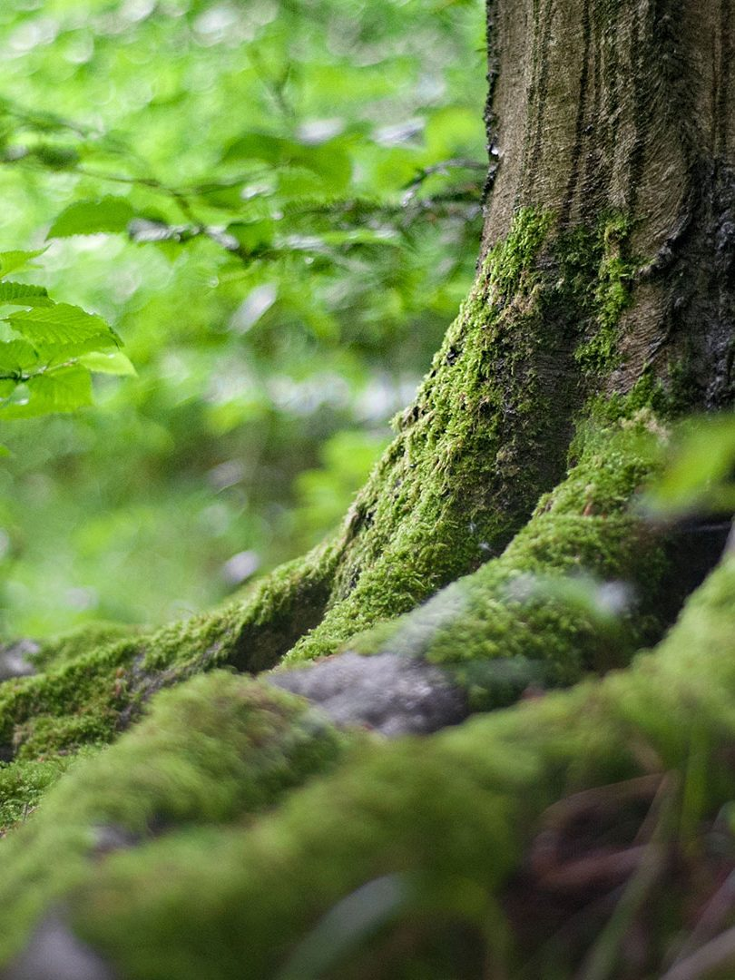

How To Live Sustainably

By Milana

🦆🦆🦆🦆🦆🦆

On the topic of water bottles, water is also something that us humans tend to overuse in our daily lives. The average Australian household can use up to 340 liters of water per day! Now, multiply that by about 25 million for every household in Australia, and you’ll realize how much water just one continent uses *per day.*So, how can we work on lowering the amount of water that we use each day? Well, I’m sure we can all start with taking shorter showers and using less water if bathing. Also, unnecessary use of water in things like watering gardens too much/too often.

But first, before we can talk about being sustainable in your environment and community, we need to look at being mentally sustainable. It might sound weird, like, how can you be mentally sustainable? What, you clean up the rubbish in your brain? Well, no, that’s not what it means. There can be two definitions for this. The first one is basically, when being mentally sustainable is the act of having safe and healthy mentality practices, such as and for example, being happy or thinking positively about yourself and others. Some things that can help with this is generosity, giving back, or just treating yourself! Or, sometimes, people can turn to nature to help with peace and keeping your sanity in our crazy world. But too much of peace and relaxation and self-treatment can sometimes reach to putting yourself always first, which can spark egoistic behavior, and even some physical changes. Another possible definition of mental sustainability is the effects that being sustainable in the world around us can do to the brain, in positive ways, but we will come back to this definition, as we explore the other ways of living sustainably.

Imagine a beautiful world, where we can breathe freely and live peaceful lives. But the world just isn’t like that. We are surrounded by machines, people, chaos, and pollution. We’ve evolved so much over the past few centuries, that humans have forgotten how to live sustainably. When we think of the word sustainable, things and words like ‘environment’ and ‘green’ come into our minds, but we don’t think of things like mental sustainability, which is like keeping yourself sane in the chaos that we live in. Read along, and together, let’s find out how to live sustainably in 21st century.

Now, let’s look at the ways that we can be sustainable in our living areas, at home, at work/school, and even in our neighborhoods. I’m sure that you’ve seen posters that say, “put your rubbish in the bin” or “keep our areas clean” and, they’re right. As repetitive as they might be, they are quite right. One way to keep our communities clean is by picking up small pieces of litter and putting our own rubbish in the bins.

Another way to reduce the amount of waste that we use is to stop using as much paper and other things such as plastic. The problem with paper is that it’s typically made from non-recycled wood, which is one of the leading causes of deforestation. Plastic, is also not usually recycled and reused, and it is toxic for nature. Plastic can take up to hundreds of years to fully disintegrate or break down. This is why people need to start checking tags to find recycled items and use those instead of brand-new ones. Water bottles, some straws and plastic bags at the stores are now made from recycled plastic which is definitely a step in the right direction.

Sustainability is one of the most important ways to keep our world in order, keep our world healthy and safe from global warming. Our world is at a point where it is extremely vulnerable to any changes in climate, and these can result in catastrophic disasters. For example, the melting of icebergs will rise sea levels and that could result in cities, towns and even small countries being covered by water. It will also mean that many animals will go extinct. As for littering and deforestation, this could also result in the extinction of many different animals. So, next time you read one of those “Don’t litter” posters, stop and think, and look at the bigger picture, which is frankly, our world in the next few decades. You can choose to be sustainable or live your life as you are right now.